Experiment No. 12

Aim: To implement Parallel Algorithms.
Theory:
Parallel Computing is defined as the process of distributing a larger task into a small number of independent tasks and then solving them using multiple processing elements simultaneously. Parallel computing is more efficient than the serial approach as it requires less computation time.

Parallel Algorithm Models
The need for a parallel algorithm model arises in order to understand the strategy that is used for the partitioning of data and the ways in which these data are being processed. Therefore every model being used provides proper structuring based on two techniques. They are as follows:
- Selection of proper partitioning and mapping techniques.
- Proper use of strategy in order to reduce the interaction.

Types of Parallel Models

1. The Data-Parallel Model
The data-parallel model algorithm is one of the simplest models of all other parallel algorithm models. In this model, the tasks that need to be carried out are identified first and then mapped to the processes. This mapping of tasks onto the processes is being done statically or semi-statically. In this model, the task that is being performed by every process is the same or identical but the data on which these operations or tasks are performed is different.
The problem to be solved is divided into a number of tasks on the basis of data partitioning. Here data partitioning is being used because all the operations performed by each process are similar and proper uniform partitioning of data followed by static mapping assures the proper load balancing.
Example: Dense Matrix Multiplication
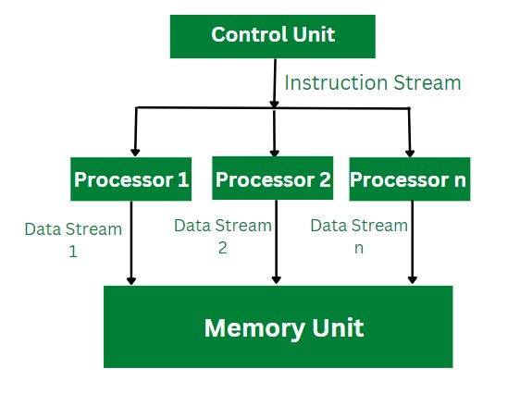
Dense Matrix Multiplication
In the above example of dense matrix multiplication, the instruction stream is being divided into the available number of processors. Each processor computes the data stream it is allocated with and accesses the memory unit for read and write operation. As shown in the above figure, the data stream 1 is allocated to processor 1, once it computes the calculation the result is being stored in the memory unit.

2. The Task Graph Model
The task dependency graph is being used by the parallel algorithms for describing the computations it performs. Therefore, the use of interrelationships among the tasks in the task dependency graph can be used for reducing the interaction costs.
This model can be used effectively for solving problems in which tasks are associated with a large amount of data as compared to that actual computation. The parallelism that is described with the task dependency graph where each task is an independent task is known as task parallelism. The task graph model is majorly used for the implementation of parallel quick sort, a parallel algorithm based on divide and conquer.

Example: Finding the minimum number
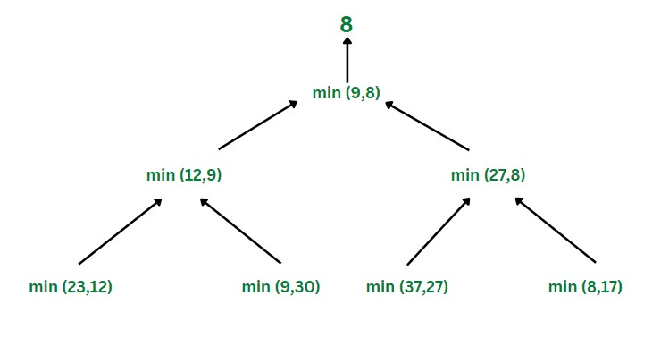

Finding the Minimum Number
In the above example of finding the minimum number, the task graph model works parallelly in order to find the minimum number in the given stream. As shown in the above figure, the minimum of 23 and 12 is computed and passed on further by one process, similarly at the same time the minimum of 9 and 30 is calculated and passed on to the further process. This approach of computation requires less time and effort.

3. Work Pool Model
The work pool model is also known as the task pool model. This model makes use of a dynamic mapping approach for task assignment in order to handle load balancing. The size of some processes or tasks is small and requires less time. Whereas some tasks are of large size and therefore require more time for processing. In order to avoid the inefficiency load balancing is required.
The pool of tasks is created. These tasks are allocated to the processes that are idle in the runtime. This work pool model can be used in the message-passing approach where the data that is associated with the tasks is smaller than the computation required for that task. In this model, the task is moved without causing more interaction overhead.

Example: Parallel tree search
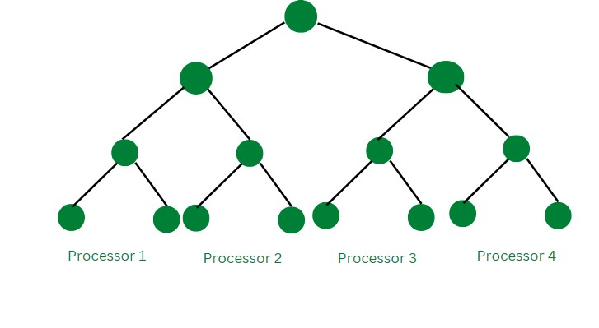

Parallel Search Tree
In the above example of the parallel search tree, that uses the work pool model for its computation uses four processors simultaneously. The four sub-tress are allocated to four processors and they carry out the search operation.

Conclusion :
The parallel algorithm model solves the large problem by dividing it into smaller parts and then solving each independent sub-task simultaneously by using its own approach. Each parallel algorithm model uses its own data partitioning and data processing strategy. However, the use of these parallel algorithm models improves the speed and efficiency of solving a particular task.

Name: Prachi Gujar
Roll no: 1 Batch: B1
Experiment no: 12

import multiprocessing def sum_of_squares (numbers, result, index):
total =sum(x*x for x in numbers) result[index] = total def parallel_sum_of_squares (numbers, num_processes):
chunk_size =len(numbers) // num_processes
chunks = [numbers[i * chunk_size: (i+1) * chunk_size] for i in range(num_processes)]

if len(numbers) % num_processes !=0:
chunks[-1].extend(numbers[num_processes* chunk_size:]) result= multiprocessing.Array('i',num_processes) processes=[]

for i in range (num_processes):
p= multiprocessing.Process(target=sum_of_squares,args=(chunks[i],result,i)) processes.append(p)
p.start()

for p in processes:
p.join()

total_sum=sum(result) return total_sum

if __name__=='__main__': n=int(input("How many No ?:")) numbers=list(range(1,n+1))
num_processes=multiprocessing.cpu_count()

total=parallel_sum_of_squares(numbers,num_processes) print(f"The sum of squres is :{total}")

Output:
